- FAMILY TREE
AIM
To write a Prolog program to implement a Family Tree using facts and rules to determine relationships such as father, mother, grandparent, and sibling.
OBJECTIVE
- To represent family relationships using Prolog facts.
- To define rules for different family relationships.
- To query the database and find relationships between family members.
- To understand the use of logical inference in Prolog.
ALGORITHM
- Start.
- Define male and female family members.
- Define parent relationships using facts.
- Define rules for father, mother, grandparent, and sibling.
- Enter a query for the required relationship.
- Prolog searches the facts and applies the rules.
- Display the matching family relationship.
- Stop.
FLOWCHART
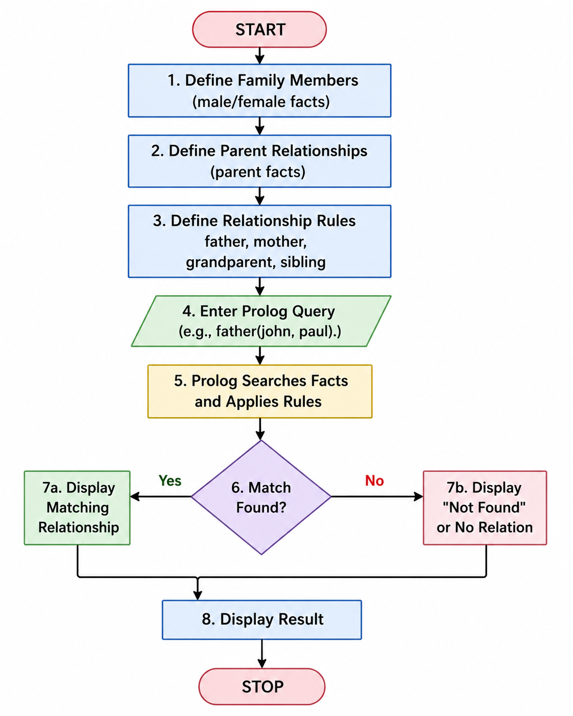
CODE:
male(john).
male(paul).
male(alex).
female(mary).
female(lisa).
female(anna).
parent(john, paul).
parent(mary, paul).
parent(john, lisa).
parent(mary, lisa).
parent(paul, alex).
parent(anna, alex).
father(X, Y) :-
male(X),
parent(X, Y).
mother(X, Y) :-
female(X),
parent(X, Y).
grandparent(X, Y) :-
parent(X, Z),
parent(Z, Y).
sibling(X, Y) :-
parent(P, X),
parent(P, Y),
X \= Y.

OUTPUT
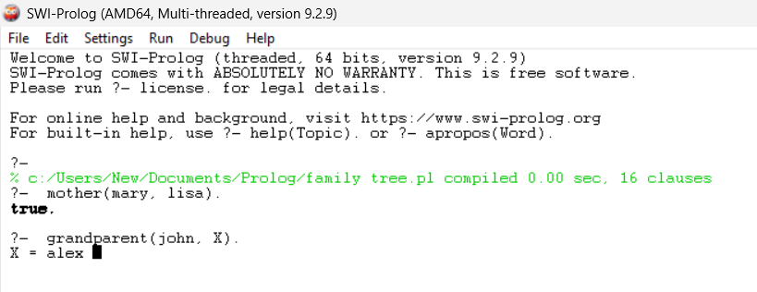
RESULT
Thus, the Family Tree was successfully implemented in Prolog, and family relationships such as father, mother, grandparent, and sibling were successfully determined using facts, rules, and queries.

